Activity 2.1: Flower design problem
Look at this flower:
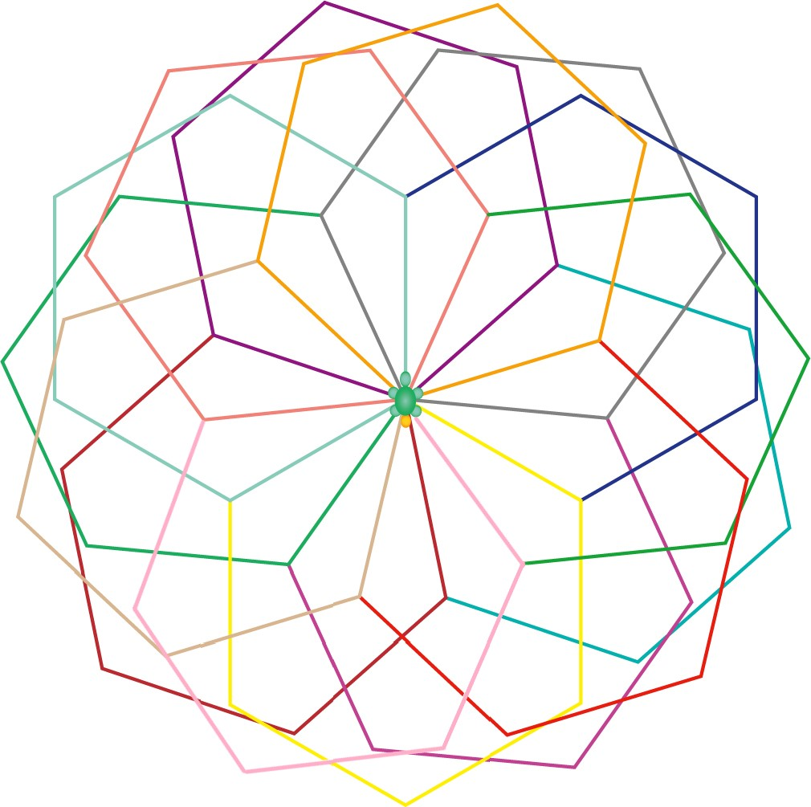
1. Identify as many patterns in the flower as you can.

2. Make a list of any elements of the design that could be removed or changed and still leave a flower design that is similar to the original flower design.

